Improving Staffing For The Hospital By 20%

XX
X University
Course code
Professor's Name
Date

Improving Staffing For The Hospital By 20%
Model formulation
Regarding our problem of improving staffing for the hospital as a whole by 20% by next January, it is prudent to understand that this concept is significant in improving patient care. Categorically, research suggests a measurable improvement of patient outcomes related to staffing, which lowers the nurses' workload (Hughes, 2008). Califonia, being the first country to implement the law that regulates the maximum patient to nurse staffing ratio, indicates a significant increment in better health outcomes, including reduced rates of surgical mortalities, reduces in-patients death within one month of admission, and reduces chances of dying from falling. Therefore, nurses need to request time-off promptly, and their gaps should be replaced with traveler nurses, thus ensuring smooth patient-support delivery.
The cybernetic illustration of the conversation process proposed below (figure 1) is probabilistic decision-making between unknowns. This model is based on two assumptions. First, the decision-maker possesses a possible event's complete list that is likely to impact the outcome. Secondly, the decision-maker is rational hence updates their beliefs when novel information is available. This assumption concludes that the decision-maker partakes the probable cost or probable-benefit analysis. However, one of the significant drawbacks of this model is failing to distinguish measurable uncertainties and immeasurable. Therefore, this model shows us that the problem is at the input phase. When nurses table their PTO requests, the nurse staffing office (decision maker) delays reviewing them, leading to a denial of time-off requests. When approved, the staffing office fails to replace the outgoing nurses (outcome).

Figure 1: Cybernetic Drawing
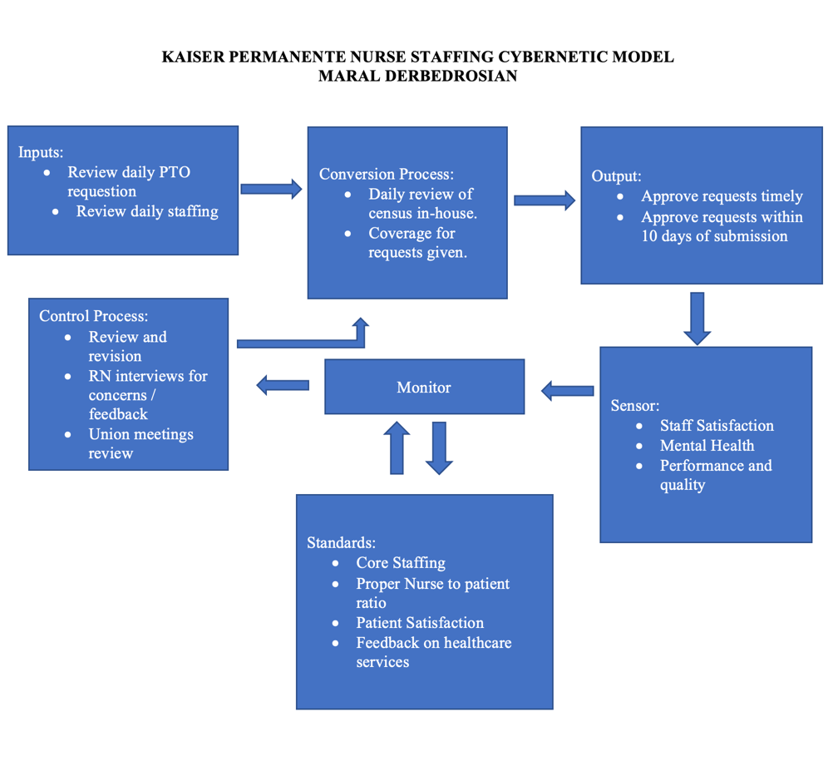
Determination of Data Requirements and Availability
In the real world, information like patient falls, pressure ulcer prevalence, falls with injury, ventilator-linked pneumonia, nursing hours per patient day, and restraint prevalence can be used to evaluate the system and staffing improvement. Consequently, these factors can lead to increased cost of treatment to the patient. The patient's understanding and complexity of their health status and their comorbid medical condition depend on the nursing care's quality in relation to evaluation and intervention's appropriate execution intended to prevent adverse events and patient outcome optimization. For example, understaffing nurses will lead to fatigue hence the poor quality of healthcare services. The market demand for nurses is high, while salaries are relatively low. Many nurses want to work on transit to acquire an extra coin which will boost their salaries.
Sources of data
variable | Sources of data | types
Staffing | - Assignment sheets, scheduling grids records from the facility's operation  - Data submitted to regulatory bodies  - Staff's survey concerning staffing levels and workload | - Staff hours divided by patient volume  - Nursing staff's credentials: licensure level, professional qualifications, years of experience  - Contract's use  - Voluntary turnover
Outcome | - Records of patients, discharge abstracts, or care delivery's by-products  - Potential surveillance for incidences like falls, pressure ulcers  - Patients and provider's survey | - Events' occurrence is suggesting the poor quality of health care.  Level of measurement  - Organizations' subunits  - Entire facilities  - Patients or nurses

Solutions to the problem
Problem: A nurse has to follow a few steps before being able to be approved for PTO. We have to ensure the unit is staffed to core RNs minus one. The problem is related to quality, costs, and provider/patient satisfaction. My aim would be to improve staffing for the hospital by 20% by next January.
Solution 1: The hospital needs to combine its resources and develop strategies that will elevate the nursing image by partnering with public relations organizations to launch an integrated marketing plan of recruiting more students into the nursing field.
Solution 2: Aging practicing nurses who are unable to manage the job's physical demands should be utilized in educating new nurses. These new nurses do not have curriculum development and measurement skills of performance, thus showing them the way forward. They can be offered locums or employed on contract hence substituting the retired nurses or time-off nurses.
Figure 2: Flowchart indicating Nurse Staffing, Care's Quality, and outcomes
Administrative practices
Staffing:
# of nursing personnel relative to service volume
Staffing:
Staff qualifications (education, experience, etc.
Model of care delivery
Organizational environment
Quantity (dose) of nursing attention
Quality of nursing care
-safety of acts
-prevention
-rescue
Care needs of population
Safety outcomes
Clinical outcomes
Figures 1 and 2 will work hand in hand to recruit travelers nurses to cater to time-off nurses. This will ensure that the hospital facility is not understaffed with nurses in patient care outcome delivery. For example, a registered nurse will submit their time-off requests timely, which will ensure that the nurse staffing office (Administrative practices that are captured in figure 1) has enough time to employ travelers nurse on a contract basis, hence filling the gap that has been left blank.

Literature Review
The shortage of nurses in the healthcare industry has been a great challenge. According to Walden University (2017) research, they came up with several approaches to improving nurse-to-patient ratios in healthcare facilities. The approaches include a favourable Working Environment, Investing in Nursing Education, Ensuring Employee Engagement, and addressing underlying causes (Wallis,2016).
Favourable working environment
A positive environment for work has been a key factor in ensuring the retention of nurses in their places of work. According to Walden University, in their research, it showed that this was a key factor. An oppressive and abusive environment has led to many nurses quitting their work which led to staffing (Wolf,2020).
Investing in Nursing Education
The healthcare organization is encouraged to invest in educating nurses, therefore, catering for the shortage. Though the provision of educational opportunities to the nurses has led to ensuring skilled nurses, which leads to quality skills, this has also encouraged many of the nurses to remain engaged and committed to their work (Wallis,2016).
Addressing underlying causes
In most cases, hospitals lose their nurses due to poor working conditions and poor wages, among other assistants. If these issues remain unsolved, eventually, the hospitals will lose all of their nurses, leading to staffing. Therefore, addressing these causes is a key factor in ensuring that the nurses are retained (King,2018).

Ensuring Employee Engagement
Trust and constant engagement of the workers in decision making and staffing plans is also a key factor. This makes the workers feel engaged, involved, and empowered, therefore ensuring commitment to their work and sharing leadership responsibilities; hence, losing such workers is not easy unless it's by retirement or any unavoidable issue (King, 2018).
Creation of a formal Staffing plan
A staffing plan can be an alternative for the nurse-to-patient ratio. The plan should be strategic and ensure that support is given to each department and address the common factors such as the number of admissions and discharge and nurse expertise level (Wolf,2020).

References
Hughes, R. (Ed.). (2008). Patient safety and quality: An evidence-based handbook for nurses.
King, L., & Drake, K. (2018). How to drive employee engagement through high-performance leadership. Nursing Management, 49(7), 7-8. https://doi.org/10.1097/01.numa.0000540053.83189.82
Wallis, L. (2016). Data again show nurse staffing improves outcomes in a variety of settings. AJN, American Journal of Nursing, 116(3), 14. https://doi.org/10.1097/01.naj.0000481262.56623.10
Wolf, L. (2020). How safe staffing can improve emergency nursing: Time to cut the Gordian knot. Emergency Nurse, 28(1), 28-32. https://doi.org/10.7748/en.2019.e1928

